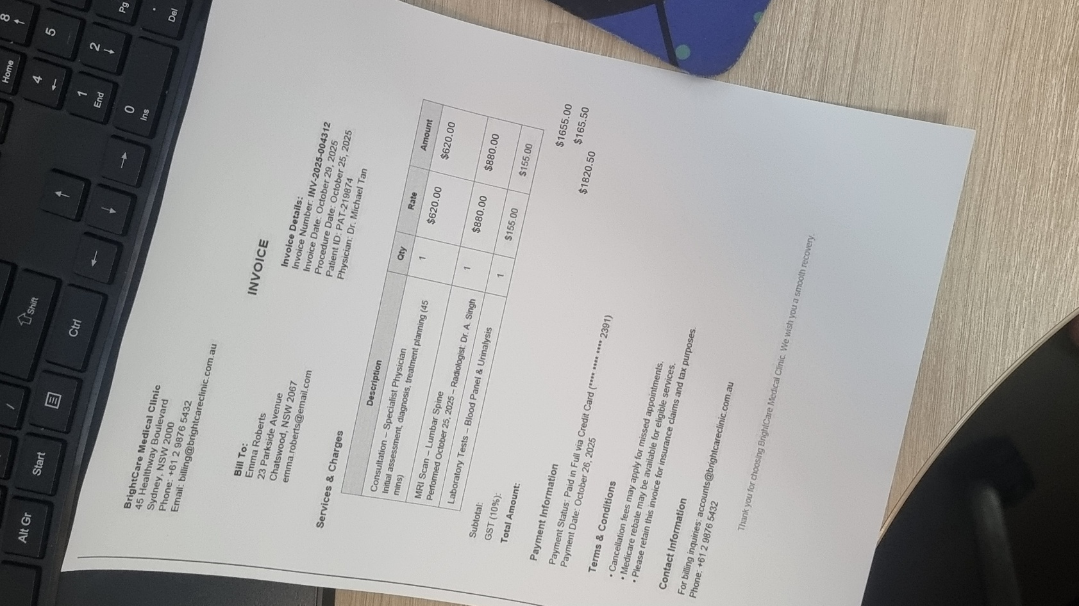
SCENARIO 1 – FRAUD – (EXTREME Units , Risky Provider)
HANDOVER TO PROTIVITY FOR FRAUD OVERVIEW
Provider ID: PRV73001 Dr Michael Tan (Specialist Physician)
CPT Code : 00215 – Office visit, Level 3
Claim Amount: $1820.50
Service Date: 29/10/2025
Days to submit: 104
Patient Age 45

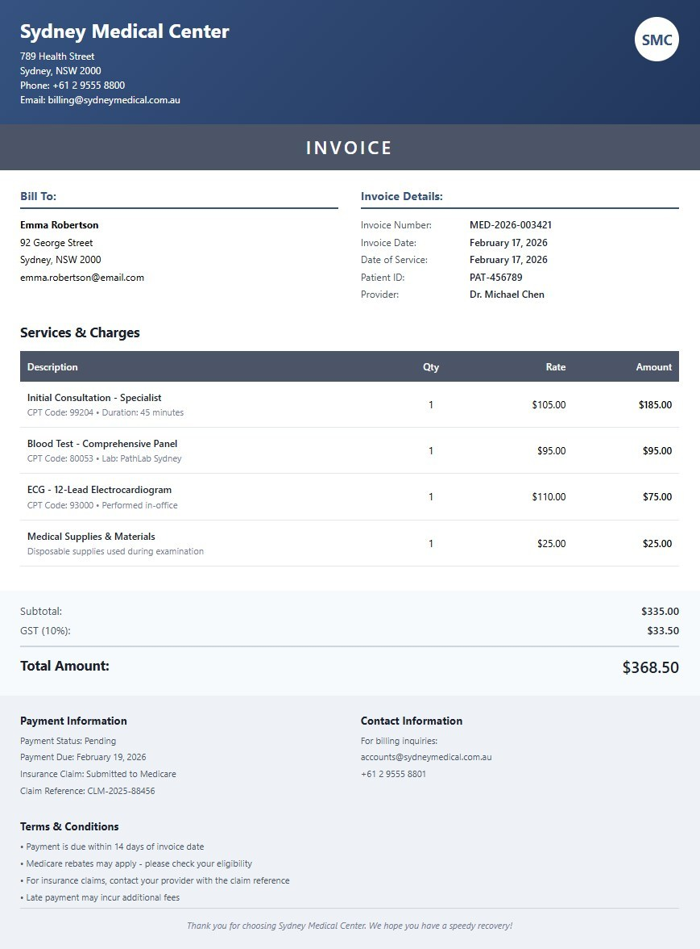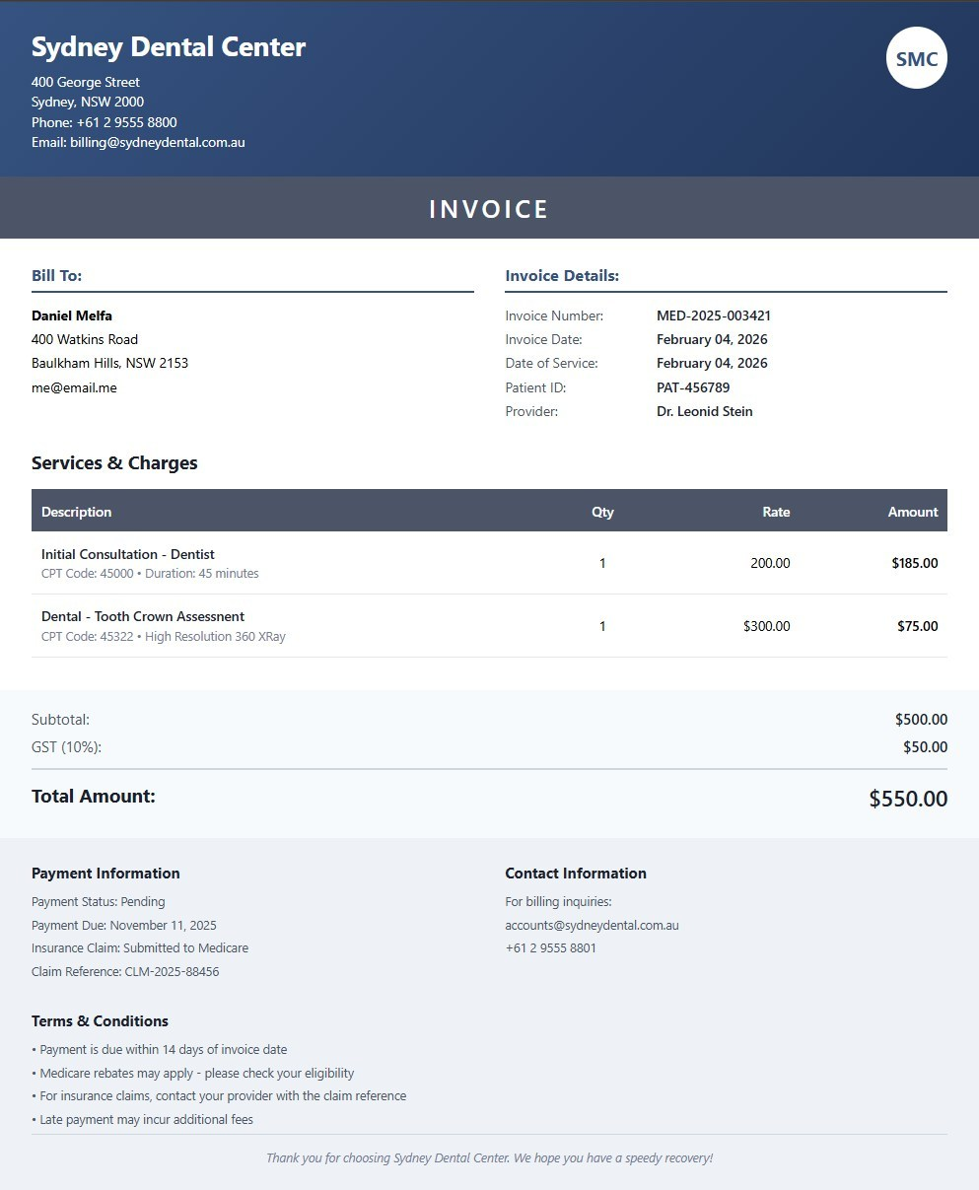
SCENARIO 2 – NO FRAUD
Provider ID: PRV74001 Dr Michael Chen (General Practitioner)
HANDOVER TO PROTIVITY FOR NO FRAUD OVERVIEW
CPT Code : 00215 – Office visit, Level 2
Claim Amount: $368.50
Service Date: 17/02/2026
Days to submit: 1
Patient Age 41

SCENARIO 3 – NO FRAUD – (Workflow NOT ELIGIBLE)
Provider ID: PRV76001 Dr Leonid Sten (Dental Surgeon)
NO HANDOVER NEEDED, DEMO INSTANCE 3
CPT Code : 00215 – Office visit, Level 3
Claim Amount: $550.00
Service Date: 04/02/2026
Days to submit: 18
Patient Age 45

